SYREN NETWORKS

Small Office / Home Office (SOHO) Network

Design & Implementation Report

1. Project Overview
XYZ Company is a fast-growing food business that is based in Eastern Australia, it serves over 2 million customers worldwide. The company is opening a new branch near the village of Bonalbo, and need a new brand-new network built from scratch – completely separate from the main headquarters network.
  - Network Requirements
- Use one CISCO router and one Cisco switch
- Have 3 separate departments, each on its own VLAN (Virtual Local Area Network)
- Each department must have a wireless access point (Wi-Fi) for devices
- All devices must get their IP addresses automatically (using DHCP)
- All departments must be able to talk to each other across VLANs
- We assume the ISP gave us the IP address 192.168.1.0
Underneath is the network problem:
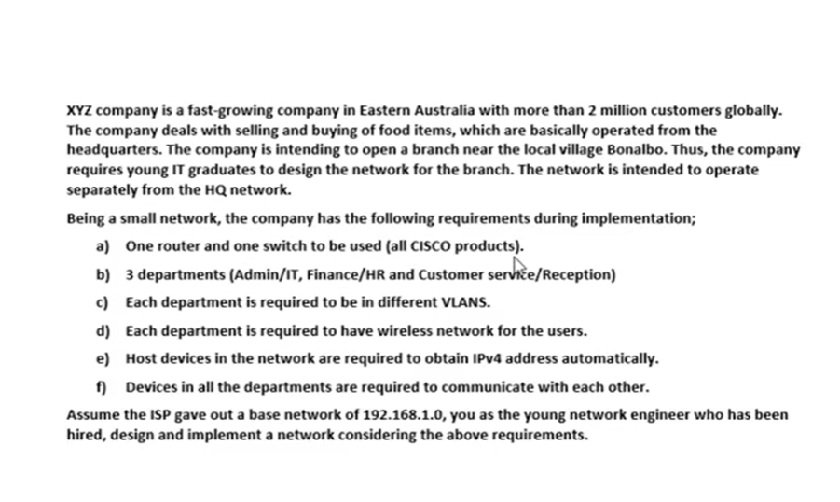

1.2 The 3 Departments
Department | VLAN Number | Wi-Fi Password | Security
ADMIN/IT | VLAN 10 | Admin@SyrenNetwork123 | WPA2-PSK
FINANCE/HR | VLAN 20 | Finance@123 | WPA2-PSK
CS/RECEPTION | VLAN 30 | Customer@123 | WPA2-PSK

2. IP Address Planning (Subnetting)
The ISP gave us the base network address 192.168.1.0. Since we have 3 departments, we needed to split (subnet) into 3 smaller networks – one for each department.

2.1 How We Calculate the Subnets
We use the VLSM (Variable Length Subnet Masking). Here is the step-by-step breakdown:
We need 3 subnets (one per department)
To get 3 more subnets we borrow 2 bits from the host portion (2² = 4 possible subnets, we use 4)
Original subnet mask (Class C): 255.255.255.0 binary: 11111111.11111111.11111111.00000000
After borrowing 2 bits the new binary form subnet mask becomes 11111111.11111111.11111111.11000000
In order for us to get the last octet we need to do the following
We raise to the power of and multiply by the bit
In order for us to get the last octet of the subnet mask we need to multiply with numbers from the right.
From 0 to 7
^ raised to
2 ^ 0 * 0 = 0
2 ^ 1 * 0 = 0
2 ^ 2 * 0 = 0
2 ^ 3 * 0 =0
2 ^ 4 * 0 = 0
2 ^ 5 * 0 = 0
2 ^ 6 * 1 = 64
2 ^ 7 * 1 = 128
64 + 128 = 192
The new subnet mask becomes 255.255.255.192 Here is the list of block sizes 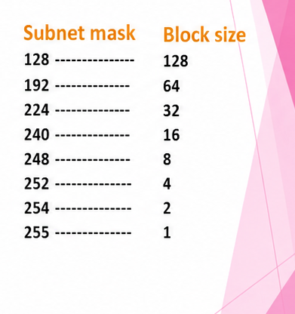
Block size tells us how to move from one subnet mask to another
In this case the block size 64

2.2 Subnet Table
VLAN | Department | Network ID | Host Range | Broadcast | Hosts
VLAN 10 | Admin/IT | 192.168.1.0 | 192.168.1.1-192.168.1.62 | 192.168.1.63 | 62
VLAN 20 | Finance/HR | 192.168.1.64 | 192.168.1.65-192.168.1.126 | 192.168.1.127 | 62
VLAN 30 | CS/Reception | 192.68.1.128 | 192.168.1.129-192.168.1.190 | 192.168.1.191 | 62

In order for us to get the Network ID we multiply network ID one by the block size.
The broadcast ID is the last IP address before we move to the next subnet. (the network ID in this case)
The range of valid host lies between the network ID and the Broadcast ID

3. VLAN Configuration (Switch Setup)
A VLAN (Virtual Local Area Network) is like drawing invisible walls between departments on the same physical switch. Devices in VLAN 10 cannot accidentally talk to devices in VLAN 20 or 30 without going through the router first.

3.1 Port Assignment
The port assignment was done directly on the switch using the CLI. Here is exactly what was typed:

! --- Enable privileged mode ---
Switch> en
Switch# conf t

! --- VLAN 10: Admin/IT (ports Fa0/2, Fa0/3, Fa0/4) ---
Switch(config)# int range fa0/2-4
Switch(config-if-range)# switchport mode access
Switch(config-if-range)# switchport access vlan 10
! Output: % Access VLAN does not exist. Creating vlan 10

! --- VLAN 20: Finance/HR (ports Fa0/5, Fa0/6, Fa0/7) ---
Switch(config-if-range)# int range fa0/5-7
Switch(config-if-range)# switchport mode access
Switch(config-if-range)# switchport access vlan 20
! Output: % Access VLAN does not exist. Creating vlan 20

! --- VLAN 30: CS/Reception (ports Fa0/8, Fa0/9, Fa0/10) ---
Switch(config-if-range)# int range fa0/8-10
Switch(config-if-range)# switchport mode access
Switch(config-if-range)# switchport access vlan 30
! Output: % Access VLAN does not exist. Creating vlan 30

! --- Save the configuration ---
Switch(config-if-range)# do wr
! Output: Building configuration... [OK]

3.2 Switch Commands Used

Switch> en
Switch# conf t

! --- Assign ports to VLAN 10 (Admin/IT) ---
Switch(config)# int range fa0/2-4
Switch(config-if-range)# switchport mode access
Switch(config-if-range)# switchport access vlan 10

! --- Assign ports to VLAN 20 (Finance/HR) ---
Switch(config-if-range)# int range fa0/5-7
Switch(config-if-range)# switchport mode access
Switch(config-if-range)# switchport access vlan 20

! --- Assign ports to VLAN 30 (CS/Reception) ---
Switch(config-if-range)# int range fa0/8-10
Switch(config-if-range)# switchport mode access
Switch(config-if-range)# switchport access vlan 30
Switch(config-if-range)# do wr

3.3 Configure the Trunk Port
The port connecting the switch to the router must be set to TRUNK mode. This allows traffic from ALL VLAN’s to travel through a single cable to the router.
Switch(config)# int fa0/1
Switch(config-if)# switchport mode trunk
Switch(config-if)# do wr

4. Router Configuration (Inter-VLAN Routing)
Even though the departments are separated by VLANS, they still need to communicate with each other. This Is called Inter-VLAN Routing. We use the router to act as a traffic controller between VLANs.
We use a technique called Router-on-a-Stick – one physical router port (Gig0/0) is split into 3 virtual sub-interfaces, each one assigned to a VLAN.

4.1 Enable the Physical Interface
Router> en
Router# conf t
Router(config)# int gig0/0
Router(config-if)# no sh
Router(config-if)# do wr

4.2 Create Sub-Interfaces each VLAN
! --- Sub-interface for VLAN 10 (Admin/IT) ---
Router(config)# int gig0/0.10
Router(config-subif)# encapsulation dot1Q 10
Router(config-subif)# ip address 192.168.1.1 255.255.255.192
Router(config-subif)# ex

! --- Sub-interface for VLAN 20 (Finance/HR) ---
Router(config)# int gig0/0.20
Router(config-subif)# encapsulation dot1Q 20
Router(config-subif)# ip address 192.168.1.65 255.255.255.192
Router(config-subif)# do wr
Router(config-subif)# ex

! --- Sub-interface for VLAN 30 (CS/Reception) ---
Router(config)# int gig0/0.30
Router(config-subif)# encapsulation dot1Q 30
Router(config-subif)# ip address 192.168.1.129 255.255.255.192
Router(config-subif)# do wr

Each sub-interface gets the first usable IP in its subnet. This becomes the default gateway for all devices in that department

5. DHCP Configuration (Automatic IP Assignment)
Instead of manually typing an P address on every device, DHCP (Dynamic Host Configuration Protocol) does it automatically. When a device connects to the network, the router hands it an IP address from the correct pool.

5.1 DHCP Commands on the Router
Router(config)# service dhcp

! --- DHCP Pool for Admin/IT (VLAN 10) ---
Router(config)# ip dhcp pool Admin-Pool
Router(dhcp-config)# network 192.168.1.0 255.255.255.192
Router(dhcp-config)# default-router 192.168.1.1
Router(dhcp-config)# dns-server 192.168.1.1
Router(dhcp-config)# domain-name Admin.com
Router(dhcp-config)# exit

! --- DHCP Pool for Finance/HR (VLAN 20) ---
Router(config)# ip dhcp pool Finance-Pool
Router(dhcp-config)# network 192.168.1.64 255.255.255.192
Router(dhcp-config)# default-router 192.168.1.65
Router(dhcp-config)# dns-server 192.168.1.65
Router(dhcp-config)# domain-name Finance.com
Router(dhcp-config)# exit

! --- DHCP Pool for CS/Reception (VLAN 30) ---
Router(config)# ip dhcp pool CS-Pool
Router(dhcp-config)# network 192.168.1.128 255.255.255.192
Router(dhcp-config)# default-router 192.168.1.129
Router(dhcp-config)# dns-server 192.168.1.129
Router(dhcp-config)# domain-name CS.com
Router(dhcp-config)# exit

Router(config)# do wr

6. Wireless Access Point Configuration
Each department has its own Wireless Access Point (WAP). This lets phones, laptops, tables, and other wireless devices connect to their VLAN without needing a cable.
6.1 How to Set Up Each Access Point
Open the Access Point in Cisco Packet Tracer
Go to Port 1 settings
Set the Security Mode to WPA2-PSK
Enter the password for that department (see table in Section 1.2)
WPA2-PSK is the gold standard for Wi-Fi security. It encrypts all wireless traffic, meaning only people with the correct password can join the network.

7. Testing & Verification
After everything was configured, we tested whether devices could communicate across VLANs using the ping command.

7.1 How to Test
On any PC, go to Desktop IP Configuration and set it to DHCP
The PC should automatically receive the IP address from the router
Open the Command Prompt and ping a device in a different VLAN
A successful reply means Inter-V LAN Routing Is working correctly
! Example: From Admin PC (VLAN 10) ping Finance PC (VLAN 20)
C:\> ping 192.168.1.65

! Expected result:
Reply from 192.168.1.65: bytes=32 time<1ms TTL=255
Reply from 192.168.1.65: bytes=32 time<1ms TTL=255
Reply from 192.168.1.65: bytes=32 time<1ms TTL=255

8. Summary
Here is a quick recap of everything that was built and configured:
Subnetting: Divided 192.168.1.0 into 3 subnets using a slash notation of 26 (255.255.255.192)
Switch VLANS: Created VLAN 10,20, and 30 and assigned the correct ports
Trunk Port: Set Fa0/1 as a trunk so all VLANs can reach the router
Router Sub-Interfaces: Created Gig0/0. 10, .20, and .30 for Inter-VLAN Routing
DHCP: Configured 3address pools so all devices get automatic Ips
Wireless: Configured WPA2-PSK on 3 access points – one per department
Testing: Verified cross-VLAN communication with ping
The network is fully operational, secure and scalable. Each department is isolated on its own VLAN for security, while still being able to communicate through the router. 

